LaFerla Ortho is dedicated to delivering the best quality care for our patients while also protecting our team members. We are doing our best to adjust our schedule to accommodate these unsure times. We want to balance reducing the risk of spreading the CoronaVirus with making sure any needed treatment is provided. As part of our plan, we are trying to reduce the number of patients and those accompanying patients that visit our clinic, and we are postponing any non-vital appointments until it is safer.

INVISALIGN PROGRESS INSTRUCTIONS – CoronaVirus Protocol
Continue to wear the trays full time (and any elastics) as previously instructed. Use “chewies” as needed. Tray Fit is crucial for Invisalign to get the best results. Wear trays an average 22 hours a day for successful treatment; only removing them to eat and brush, placing them in the case provided. Continue changing trays on the planned schedule.

In order to monitor your progress we will have you take pictures of your teeth with the trays in and out. This will allow us to assess your tooth movement and then we will provide additional trays so your treatment will not be disrupted by this unforeseen complication. This procedure will also allow for you to pick up trays by simply driving into the parking lot and we will deliver the trays to your car. “Drive thru Invisalign service” will start Wednesday, March 18. Please do not show up without a scheduled time because we want to review pictures to make sure treatment is progressing.
Please take a direct front photo with the teeth open and closed with the trays in and with the trays out. Also try to take photos of left and right side views with trays out with your teeth biting together in your normal bite. Make sure to get your lips out of the pictures as best possible. Text the picture to 417-317-4546 or email the photo to admin@laferlaortho.com place “Invisalign progress photos” in the subject box with the patient’s name.
If there is an issue with your trays or retainer, continue to wear them full time in order to hold your progress. If we have completed the entire series of trays then we will need to hold until the next scan can be done or your permanent retainers can be placed. The key here is to continue to wear the trays full time so nothing relapses.
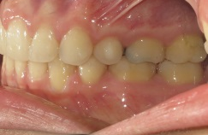
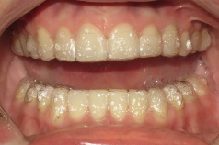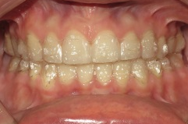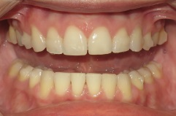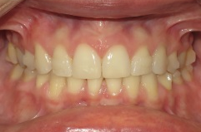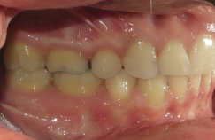
No Trays in
Left Bite
No Trays in
Right Bite
No Trays in
Closed
No Trays in
Open
Invisalign Trays in
Closed
Invisalign Trays in
Open

INVISALIGN REFINEMENT INSTRUCTIONS – CoronaVirus Protocol
As recommended by the CDC, we are trying to reduce the number of visits patients make. As part of our plan, we are asking our Invisalign patients to increase the number of days each tray is worn so we can push back your next visit to a time that the pandemic outbreak of CoronaVirus is under control. This will delay treatment but we feel the health benefit outweighs the slight treatment delay. Starting with your current trays please move to a 3 week change protocol. When you get to your last trays, continue to wear them full time until we are able to see you safely.

